**Project:**

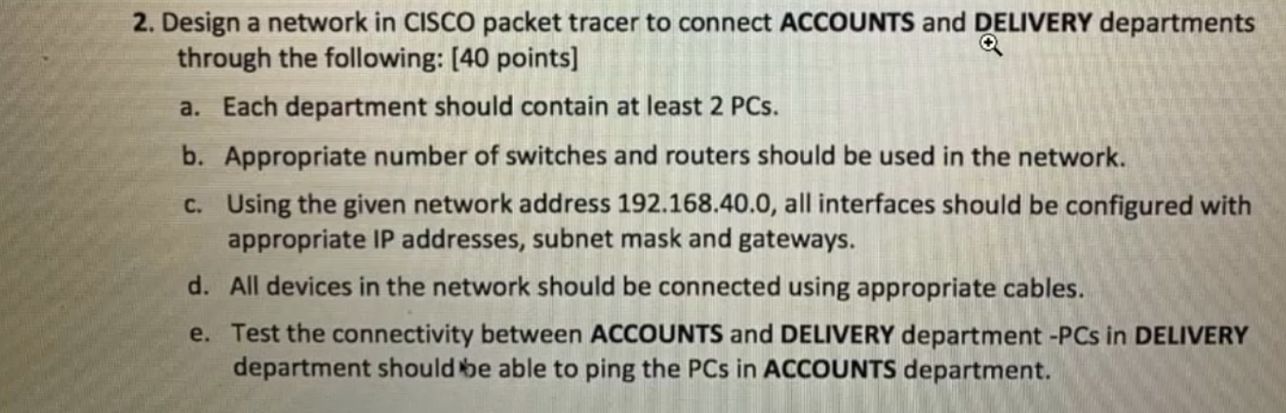

**Cisco Packet Tracer Network Diagram:**

